Technology Survey
Ms. McGarrity – 6th Grade

Student Name:_________________Parent Names:_______________________

1. How would you prefer to be contacted? Circle one or more.

Phone E-mail :_______________________ Note

2. May I call you at work? Circle one. Yes No

3. Do you have home Internet access? Yes No

4. Is your child allowed to use the Internet Yes No
for educational purposes?

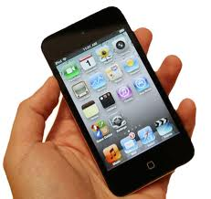
5. Would you like to receive text messages Yes No
for reminders and info.

6. Rate how well your child knows the following technology.
(5-know lots, 1-don’t know)

Navigating Internet 1 2 3 4 5

Blogs/Wikis 1 2 3 4 5

Apple iPod Touch 1 2 3 4 5

PowerPoint 1 2 3 4 5

Facebook, etc. 1 2 3 4 5

Twitter 1 2 3 4 5

Email 1 2 3 4 5

Digital Cameras 1 2 3 4 5

Word Processor 1 2 3 4 5

iPad 1 2 3 4 5

